***DATABASE TABLES CODE***

CREATE TABLE Person(

Person_ID int PRIMARY KEY,

Name VARCHAR(50),

DOB date,

Address VARCHAR(60)

);

CREATE TABLE Client(

CName VARCHAR (50),

CDOB date,

CAddress VARCHAR(60),

Rank VARCHAR(40),

Timee VARCHAR(20),

);

CREATE TABLE Coach(

CoName VARCHAR (50),

Co_DOB DATE,

Co_Addr VARCHAR (60),

Salary INTEGER,

Speciality VARCHAR (50)

);

CREATE TABLE Parking(

Parking_ID int PRIMARY KEY,

PricePerHr INTEGER

);

CREATE TABLE Courts(

Court_ID int PRIMARY KEY,

Name VARCHAR(50),

PricePerHr INTEGER,

Maxlimit INTEGER,

Minlimit INTEGER

);

CREATE TABLE Bill(

Bill_ID int PRIMARY KEY,

);

CREATE TABLE Eventss(

Event_ID int PRIMARY KEY,

EventName VARCHAR(50),

Datee DATE,

Prizes VARCHAR(50),

);

CREATE TABLE StandardRanks(

RankName VARCHAR(50) PRIMARY KEY,

RankRange INTEGER ,

Discount FLOAT

);

CREATE TABLE Attends(

Client_ID int,

Event_ID int ,

);

CREATE TABLE Organize(

Coach_ID int,

Event_ID int ,

);

CREATE TABLE Person_Phone_num(

Phone VARCHAR(11)

);

ALTER TABLE Client

ADD CONSTRAINT CLIENT_FK_1

FOREIGN KEY (Client_ID)

REFERENCES Pesron(person_id);

ALTER TABLE Client ADD CourtIDReserved int;

ALTER TABLE Client ADD CONSTRAINT CLIENT_FK_2

FOREIGN KEY (CourtIDReserved)

REFERENCES Courts(Court_ID);

ALTER TABLE Client ADD SRankName varchar(10);

ALTER TABLE Client ADD CONSTRAINT CLIENT_FK_3

FOREIGN KEY (SRankName)

REFERENCES standardranks(RankName);

ALTER TABLE coach ADD Coach_ID int;

ALTER TABLE coach ADD CONSTRAINT COACH_FK_1

FOREIGN KEY (Coach_ID)

REFERENCES Person(Person_ID);

[ALTER](http://localhost/phpmyadmin/url.php?url=https://dev.mysql.com/doc/refman/8.0/en/alter-table.html) [TABLE](http://localhost/phpmyadmin/url.php?url=https://dev.mysql.com/doc/refman/8.0/en/alter-table.html) bill ADD Client_ID int;

[ALTER](http://localhost/phpmyadmin/url.php?url=https://dev.mysql.com/doc/refman/8.0/en/alter-table.html) [TABLE](http://localhost/phpmyadmin/url.php?url=https://dev.mysql.com/doc/refman/8.0/en/alter-table.html) bill ADD CONSTRAINT BILL_FK_1 FOREIGN KEY (Client_ID) REFERENCES Client(Client_ID);

ALTER TABLE bill ADD Parking_ID int;

ALTER TABLE bill ADD CONSTRAINT BILL_FK_2 FOREIGN KEY (Parking_ID) REFERENCES parking(Parking_ID);

ALTER TABLE bill ADD Park_Name varchar(2);

[ALTER](http://localhost/phpmyadmin/url.php?url=https://dev.mysql.com/doc/refman/8.0/en/alter-table.html) [TABLE](http://localhost/phpmyadmin/url.php?url=https://dev.mysql.com/doc/refman/8.0/en/alter-table.html) bill ADD CONSTRAINT BILL_FK_5 FOREIGN KEY (Park_Name) REFERENCES parking(ParkName);

ALTER TABLE bill ADD Court_ID int;

ALTER TABLE bill ADD CONSTRAINT BILL_FK_3 FOREIGN KEY (Court_ID) REFERENCES courts(Court_ID);

ALTER TABLE eventss ADD StandardRankName varchar(10);

ALTER TABLE eventss ADD CONSTRAINT EVENTS_FK_1 FOREIGN KEY (StandardRankName) REFERENCES StandardRanks(RankName);

ALTER TABLE attends ADD CONSTRAINT ATTENDS_FK_1 FOREIGN KEY (Client_ID) REFERENCES client(Client_ID);

ALTER TABLE attends ADD CONSTRAINT ATTENDS_FK_2 FOREIGN KEY (Event_ID) REFERENCES eventss(Event_ID);

[ALTER](http://localhost/phpmyadmin/url.php?url=https://dev.mysql.com/doc/refman/8.0/en/alter-table.html) [TABLE](http://localhost/phpmyadmin/url.php?url=https://dev.mysql.com/doc/refman/8.0/en/alter-table.html) organize ADD CONSTRAINT ORGANIZE_FK_1 FOREIGN KEY (Coach_ID) REFERENCES coach(Coach_ID);

ALTER TABLE organize ADD CONSTRAINT ORGANIZE_FK_2 FOREIGN KEY (Event_ID) REFERENCES eventss(Event_ID);

ALTER TABLE person_phone_num ADD Person_ID INT;

ALTER TABLE person_phone_num ADD CONSTRAINT PHONE_FK_1 FOREIGN KEY (Person_ID) REFERENCES person(Person_ID);

// inserting in the person table

INSERT INTO person VALUES (2,'Nadeen','2000-04-24','Kafr Abdou');

INSERT INTO person VALUES (3,'Shams','2001-05-08','Kafr Abdou');

INSERT INTO person VALUES (4,'Sherine','2003-02-28','Smouha');

INSERT INTO person VALUES (5,'Alaa','2001-08-28','Gleem');

INSERT INTO person VALUES (6,'Loay','2001-08-08','Cleopatra');

// inserting in the coaches table

INSERT INTO coach VALUES ('Sherine','2003-02-28','Smouha',10000,'Padel',4);

INSERT INTO coach VALUES ('Alaa','2001-08-28','Gleem',2500,'Football',5);

INSERT INTO coach VALUES ('Loay','2001-08-08','Cleopatra',5000,'Tennis',6);

// inserting in the client table

INSERT INTO client VALUES (1,'Shady','2001-04-04','smouha',3,’Gold’);

INSERT INTO client VALUES (2,'Nadeen','2000-04-24','Kafr Abdou',1,’Gold’);

INSERT INTO client VALUES (3,'Shams','2001-05-08','Kafr Abdou',1,’Gold’);

// inserting in the courts table

INSERT INTO courts VALUES (1,'Padel',150,4,2);

INSERT INTO courts VALUES (2,'Tennis',125,4,2);

INSERT INTO courts VALUES (3,'Football',50,12,10);

// inserting in the standardranks table

INSERT INTO standardranks VALUES ('Gold',50,0.40);

INSERT INTO standardranks VALUES ('Silver',25,0.25);

INSERT INTO standardranks VALUES ('Bronze',10,0.1);

// inserting in the parking table

INSERT INTO parking VALUES (2,'1A',20);

INSERT INTO parking VALUES (3,'2A',20);

INSERT INTO parking VALUES (4,'3A',20);

INSERT INTO parking VALUES (5,'4A',20);

INSERT INTO parking VALUES (6,'5A',20);

INSERT INTO parking VALUES (7,'6A',20);

INSERT INTO parking VALUES (8,'7A',20);

INSERT INTO parking VALUES (9,'8A',20);

INSERT INTO parking VALUES (10,'9A',20);

INSERT INTO parking VALUES (11,'1B',20);

INSERT INTO parking VALUES (12,'2B',20);

INSERT INTO parking VALUES (13,'3B',20);

INSERT INTO parking VALUES (14,'4B',20);

INSERT INTO parking VALUES (15,'5B',20);

INSERT INTO parking VALUES (16,'6B',20);

INSERT INTO parking VALUES (17,'7B',20);

INSERT INTO parking VALUES (18,'8B',20);

INSERT INTO parking VALUES (19,'9B',20);

INSERT INTO parking VALUES (20,'1C',20);

INSERT INTO parking VALUES (21,'2C',20);

INSERT INTO parking VALUES (22,'3C',20);

INSERT INTO parking VALUES (23,'4C',20);

INSERT INTO parking VALUES (24,'5C',20);

INSERT INTO parking VALUES (25,'6C',20);

INSERT INTO parking VALUES (26,'7C',20);

INSERT INTO parking VALUES (27,'8C',20);

INSERT INTO parking VALUES (28,'9C',20);

INSERT INTO parking VALUES (29,'2D',20);

INSERT INTO parking VALUES (30,'3D',20);

INSERT INTO parking VALUES (31,'4D',20);

INSERT INTO parking VALUES (32,'5D',20);

INSERT INTO parking VALUES (33,'6D',20);

INSERT INTO parking VALUES (34,'7D',20);

INSERT INTO parking VALUES (35,'8D',20);

INSERT INTO parking VALUES (36,'9D',20);

// inserting in the events table

INSERT INTO eventss VALUES (1,'Gold Event',2023-01-24,'Ticket Greece','Gold');

INSERT INTO eventss VALUES (2,'Silver Event',2023-01-25,'Trip to Dahab','Silver');

INSERT INTO eventss VALUES (3,'Bronze Event',2023-01-26,'Trip to Fayoum','Bronze');

// inserting in the organize table

INSERT INTO organize VALUES (4,1);

INSERT INTO organize VALUES (5,2);

INSERT INTO organize VALUES (6,3);

// inserting in the person_phone_num table

INSERT INTO person_phone_num VALUES (01552130472,1);

INSERT INTO person_phone_num VALUES (01275599292,2);

INSERT INTO person_phone_num VALUES (01062898437,3);

INSERT INTO person_phone_num VALUES (01010101010,4);

INSERT INTO person_phone_num VALUES (01112131415,5);

INSERT INTO person_phone_num VALUES (01225897231,6);

// inserting in the attends table

INSERT INTO attends VALUES (1,1);

INSERT INTO attends VALUES (2,2);

INSERT INTO attends VALUES (3,3);

// inserting in the bills table

INSERT INTO bill VALUES (1,1,'Shady',1,'1A');

INSERT INTO bill VALUES (2,2,'Nadeen',2,'2A');

INSERT INTO bill VALUES (3,3,'Shams',3,'3A');

//Table Person

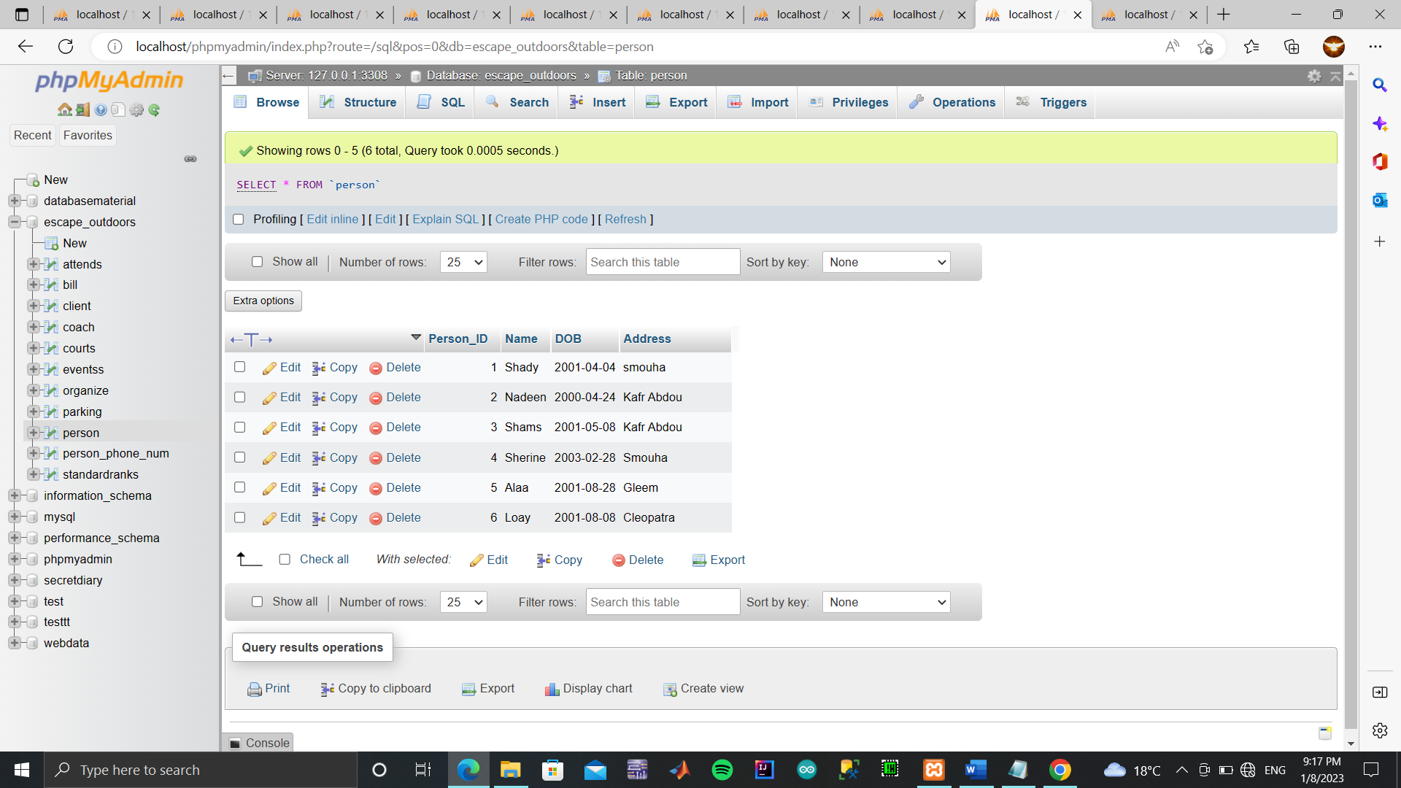

//Table Client

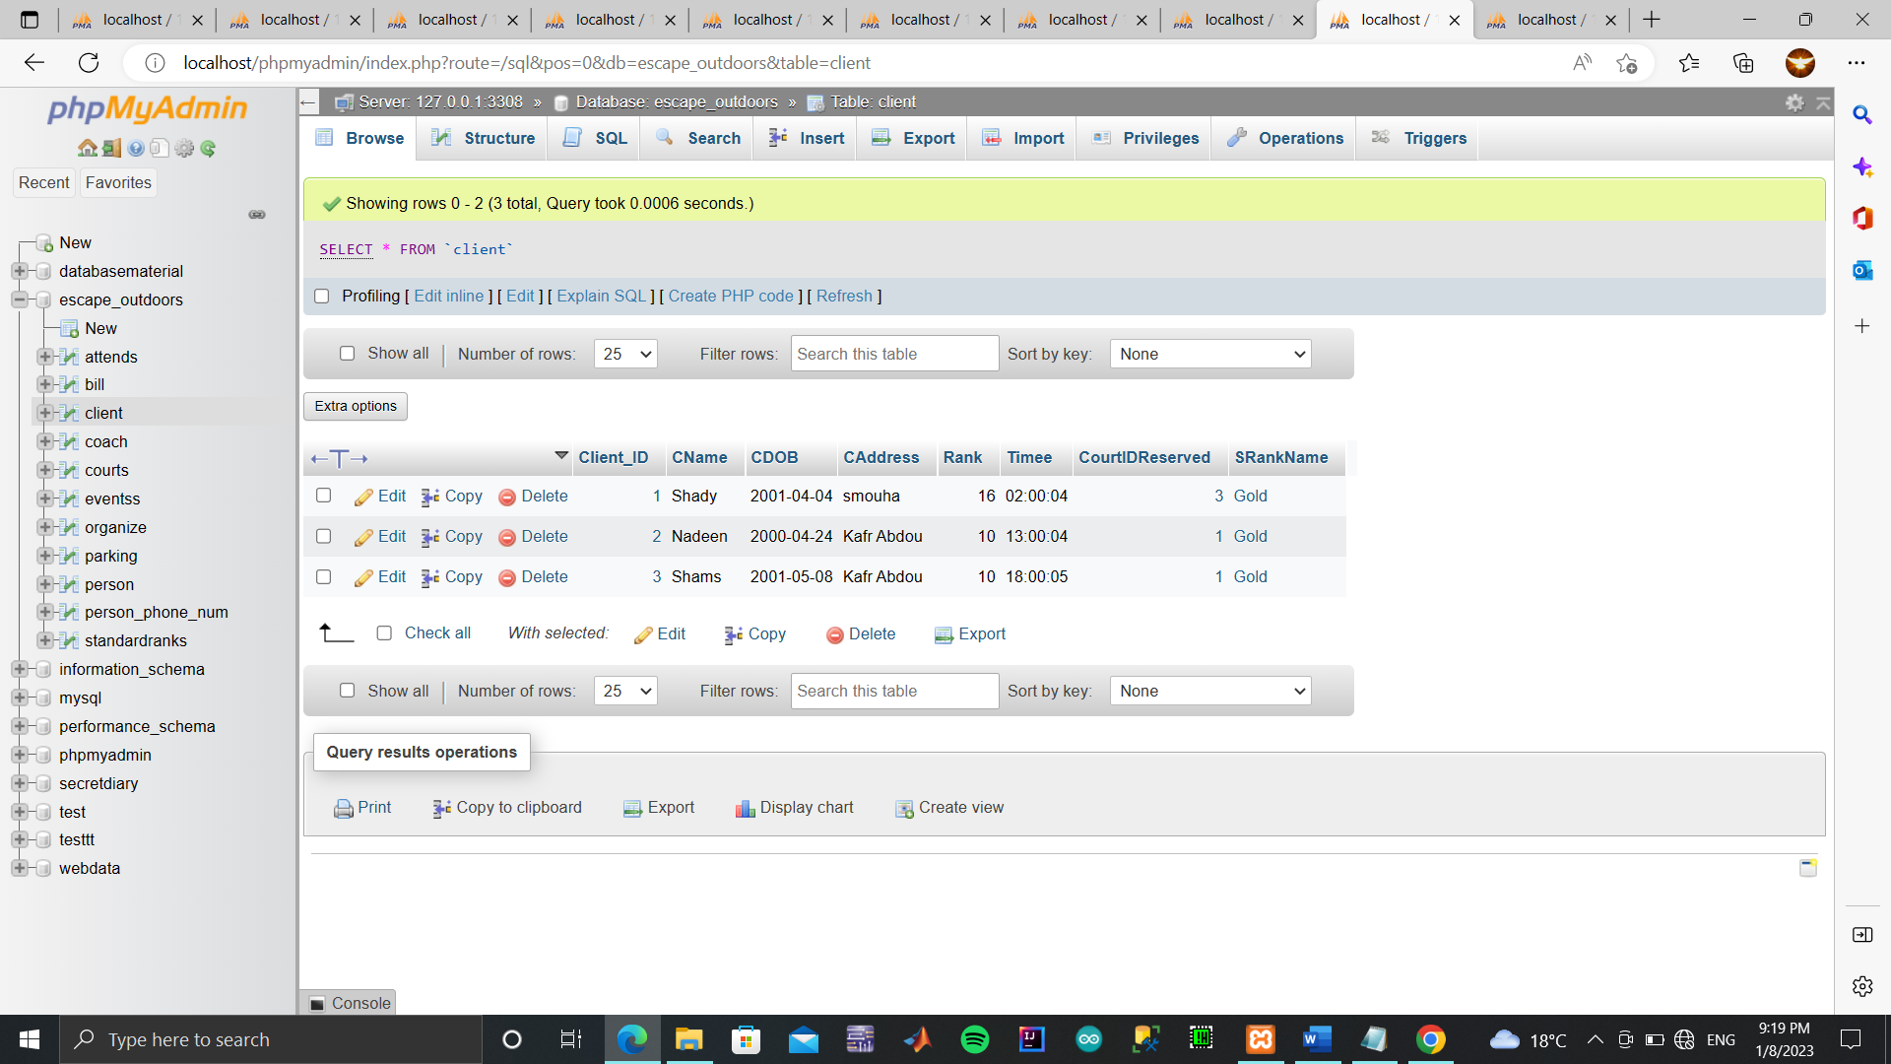

//Table Coach

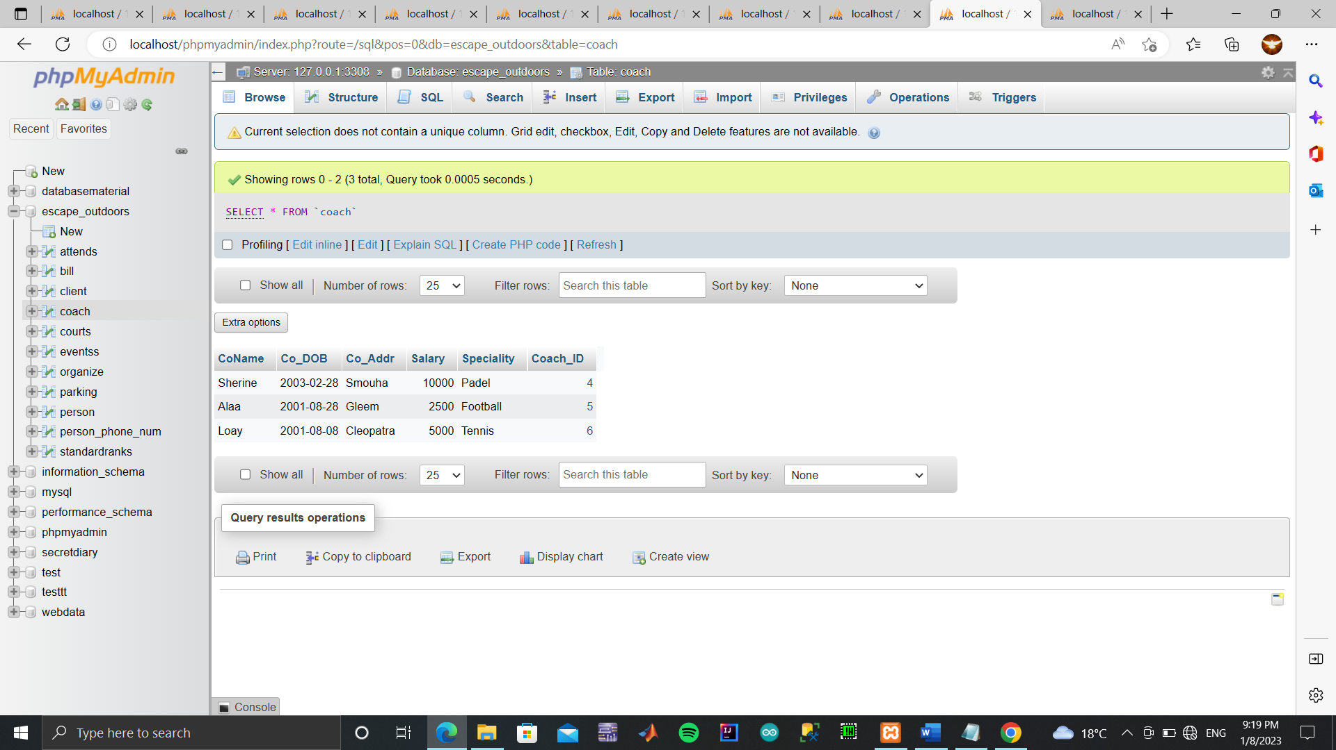

//Table Evtentss

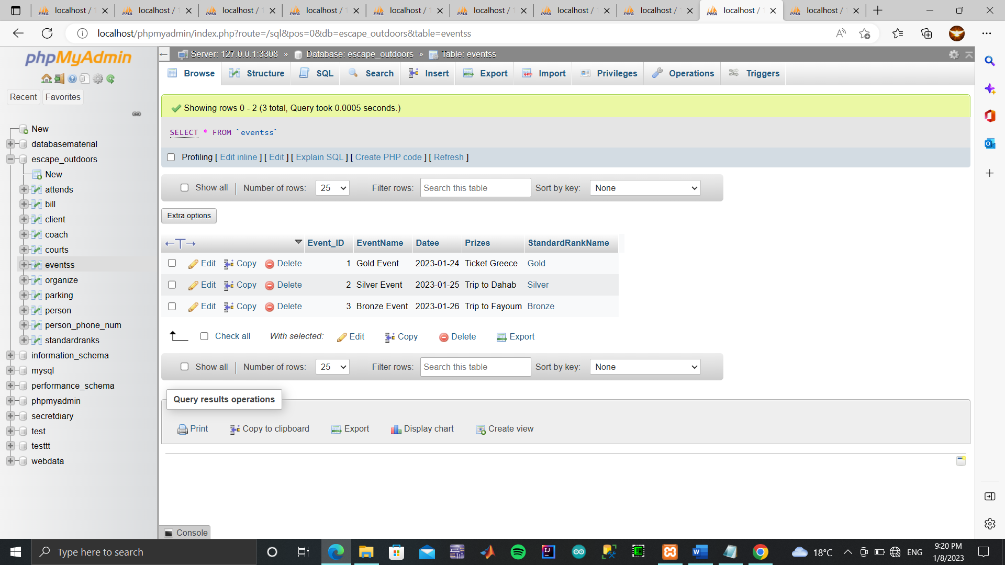

//Table Courts

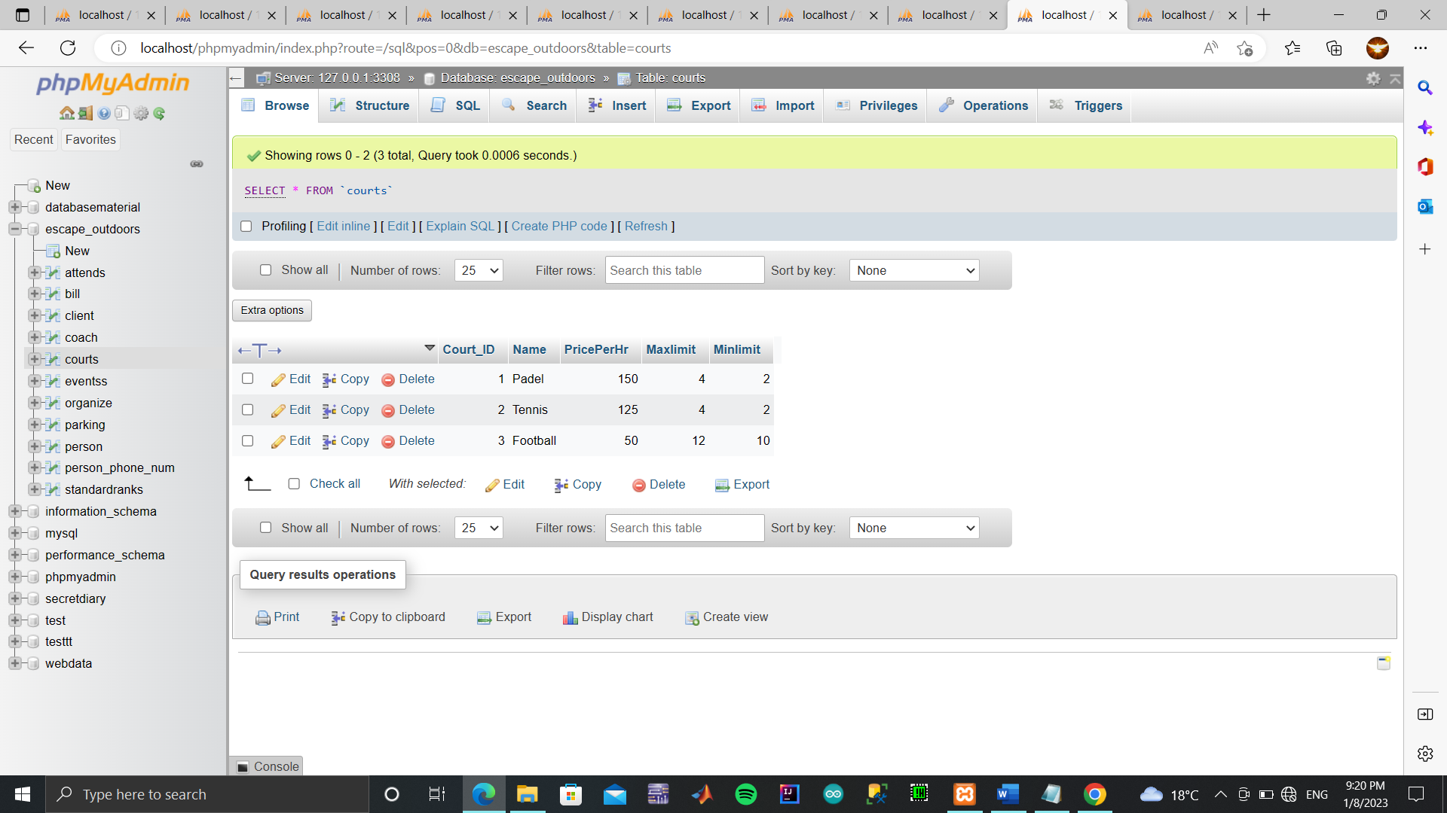

//Table Organize

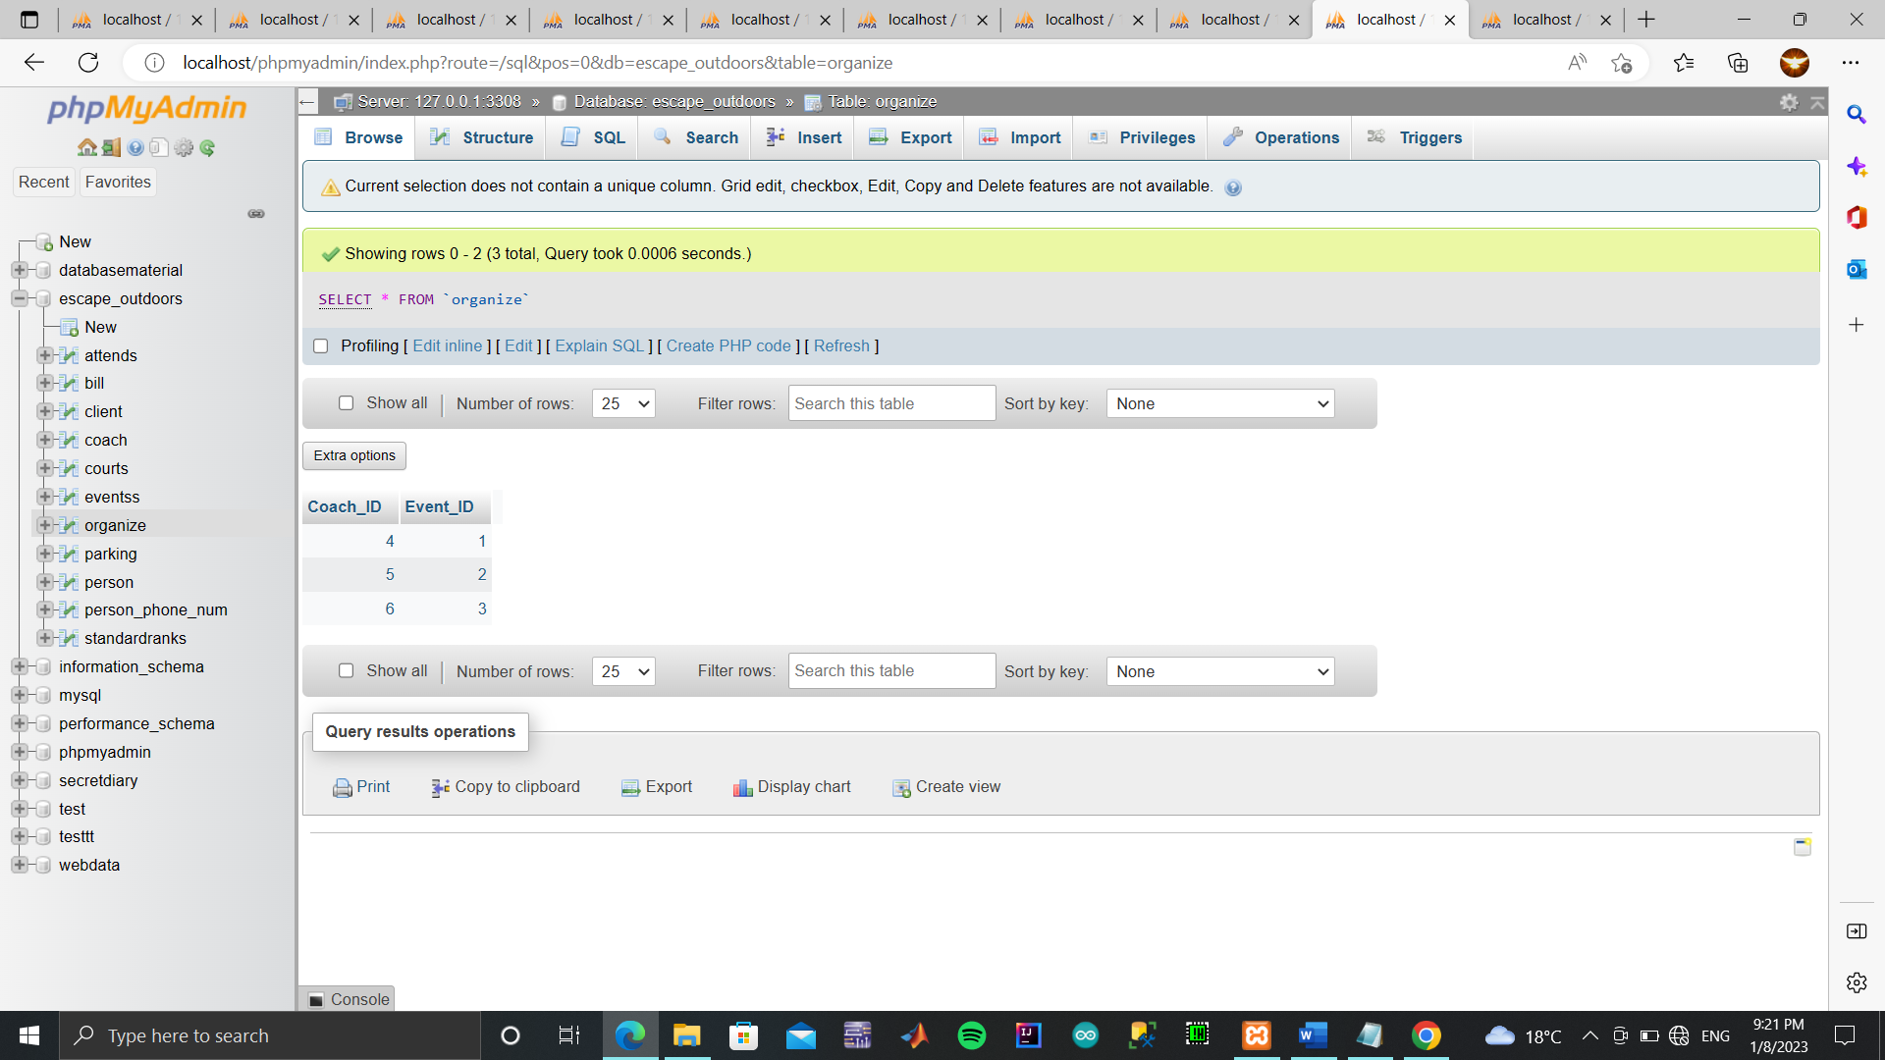

//Table Parking

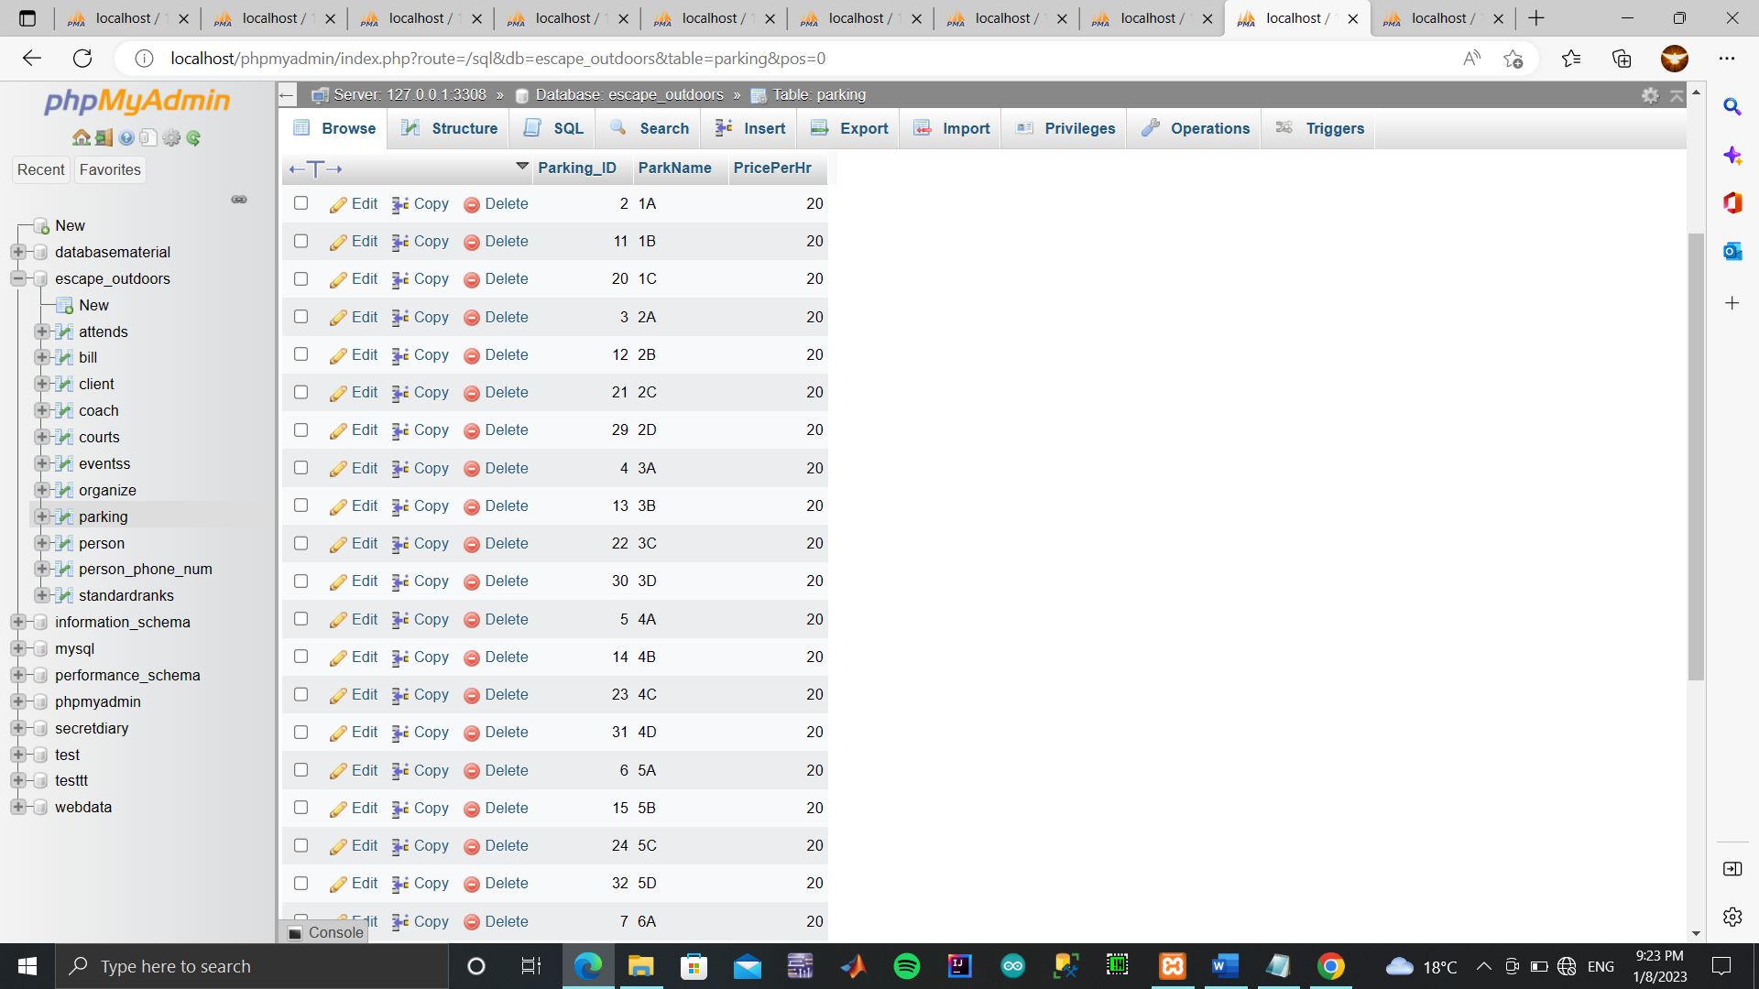

//Table StandardRanks

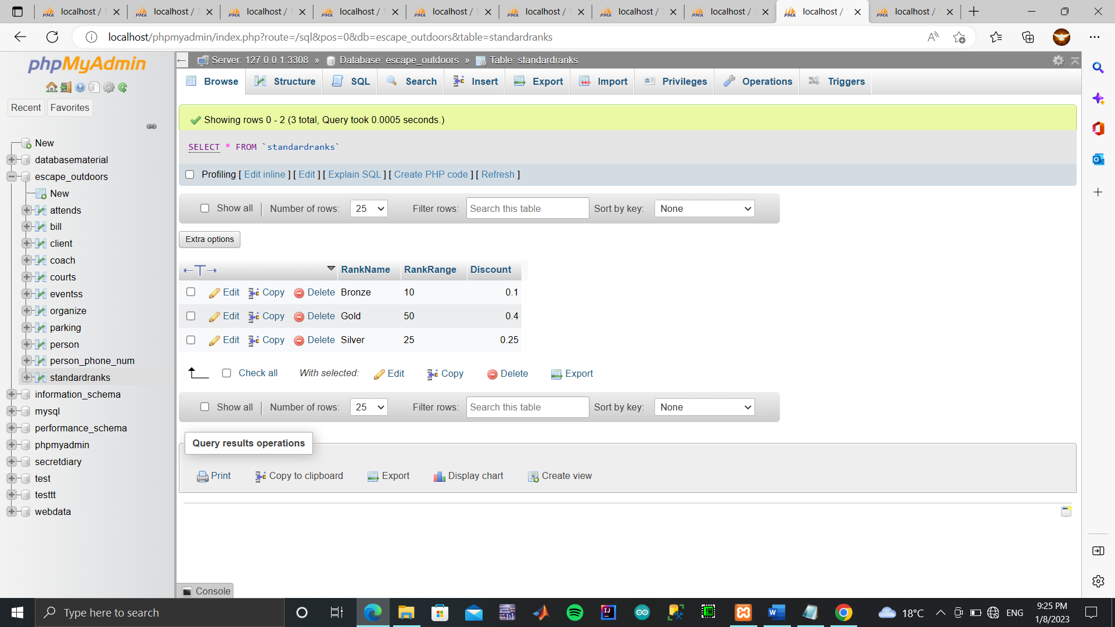

//Table Person Phone num

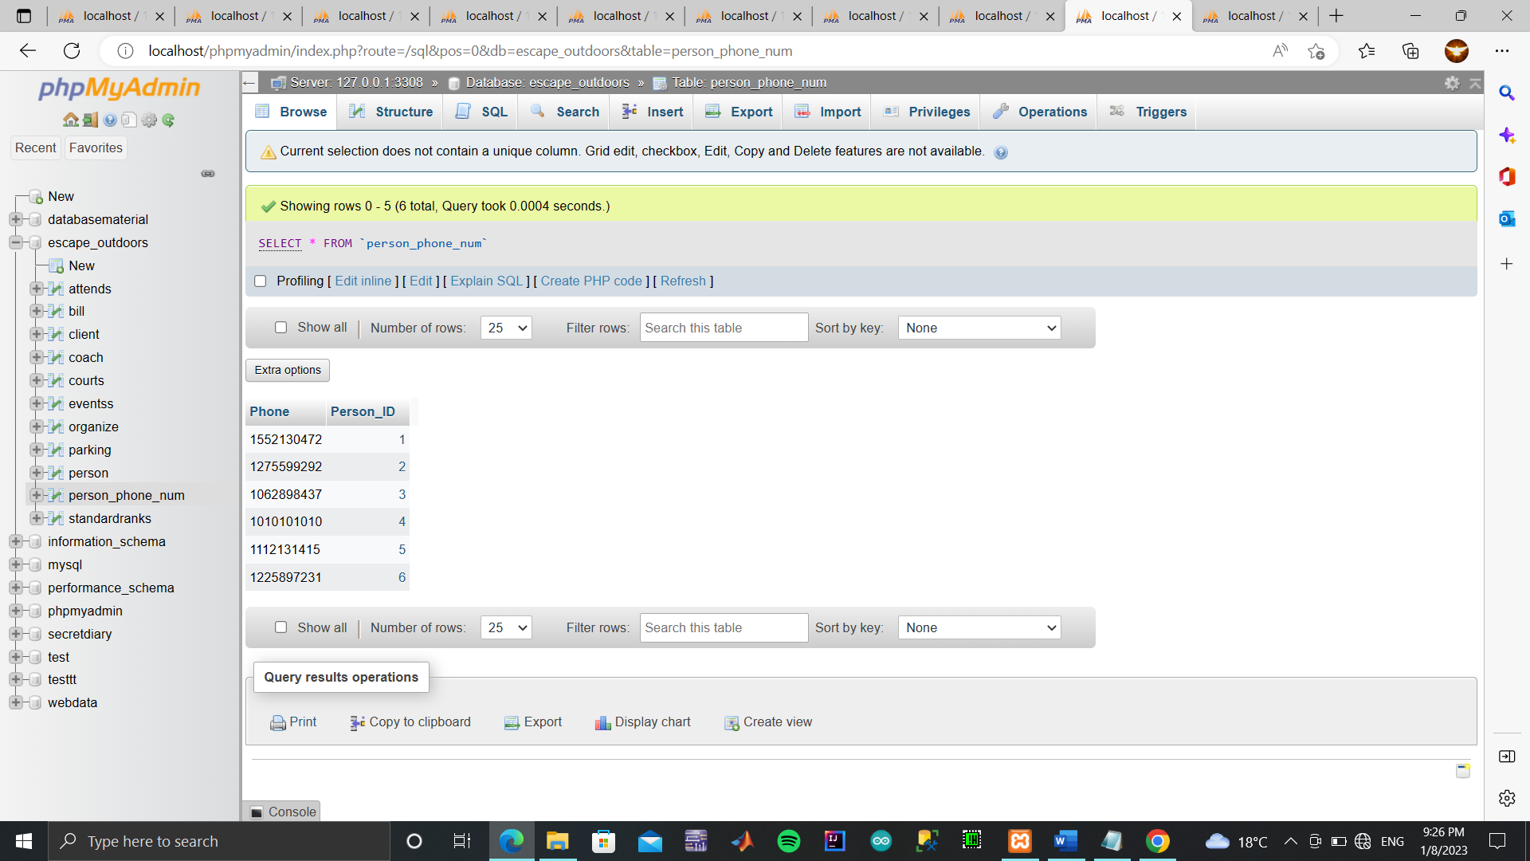

//Table Attends

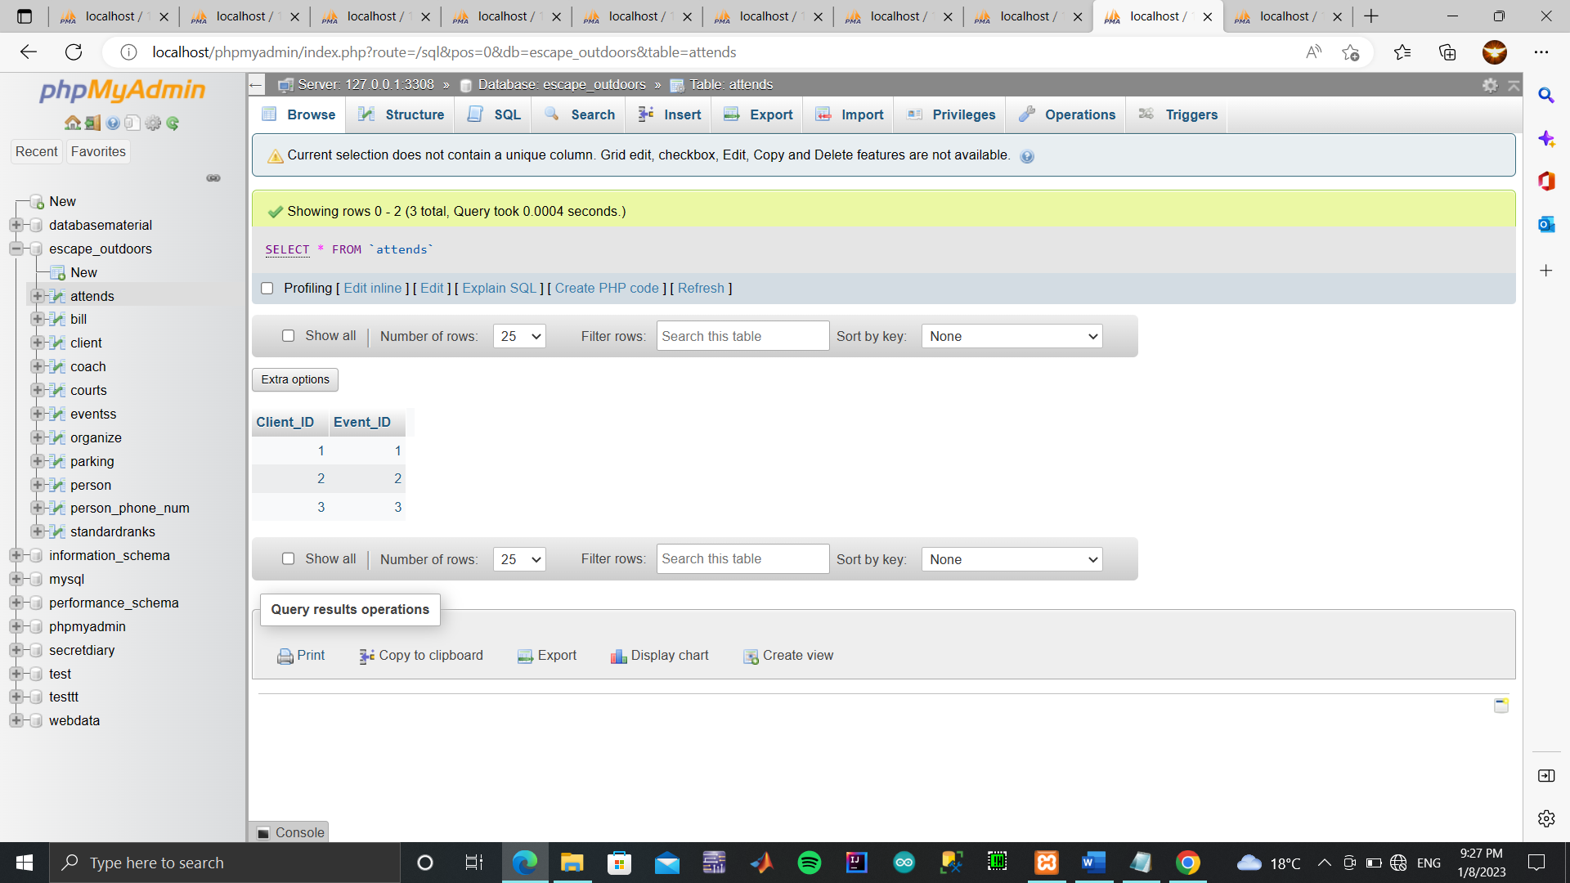

//Table Bill

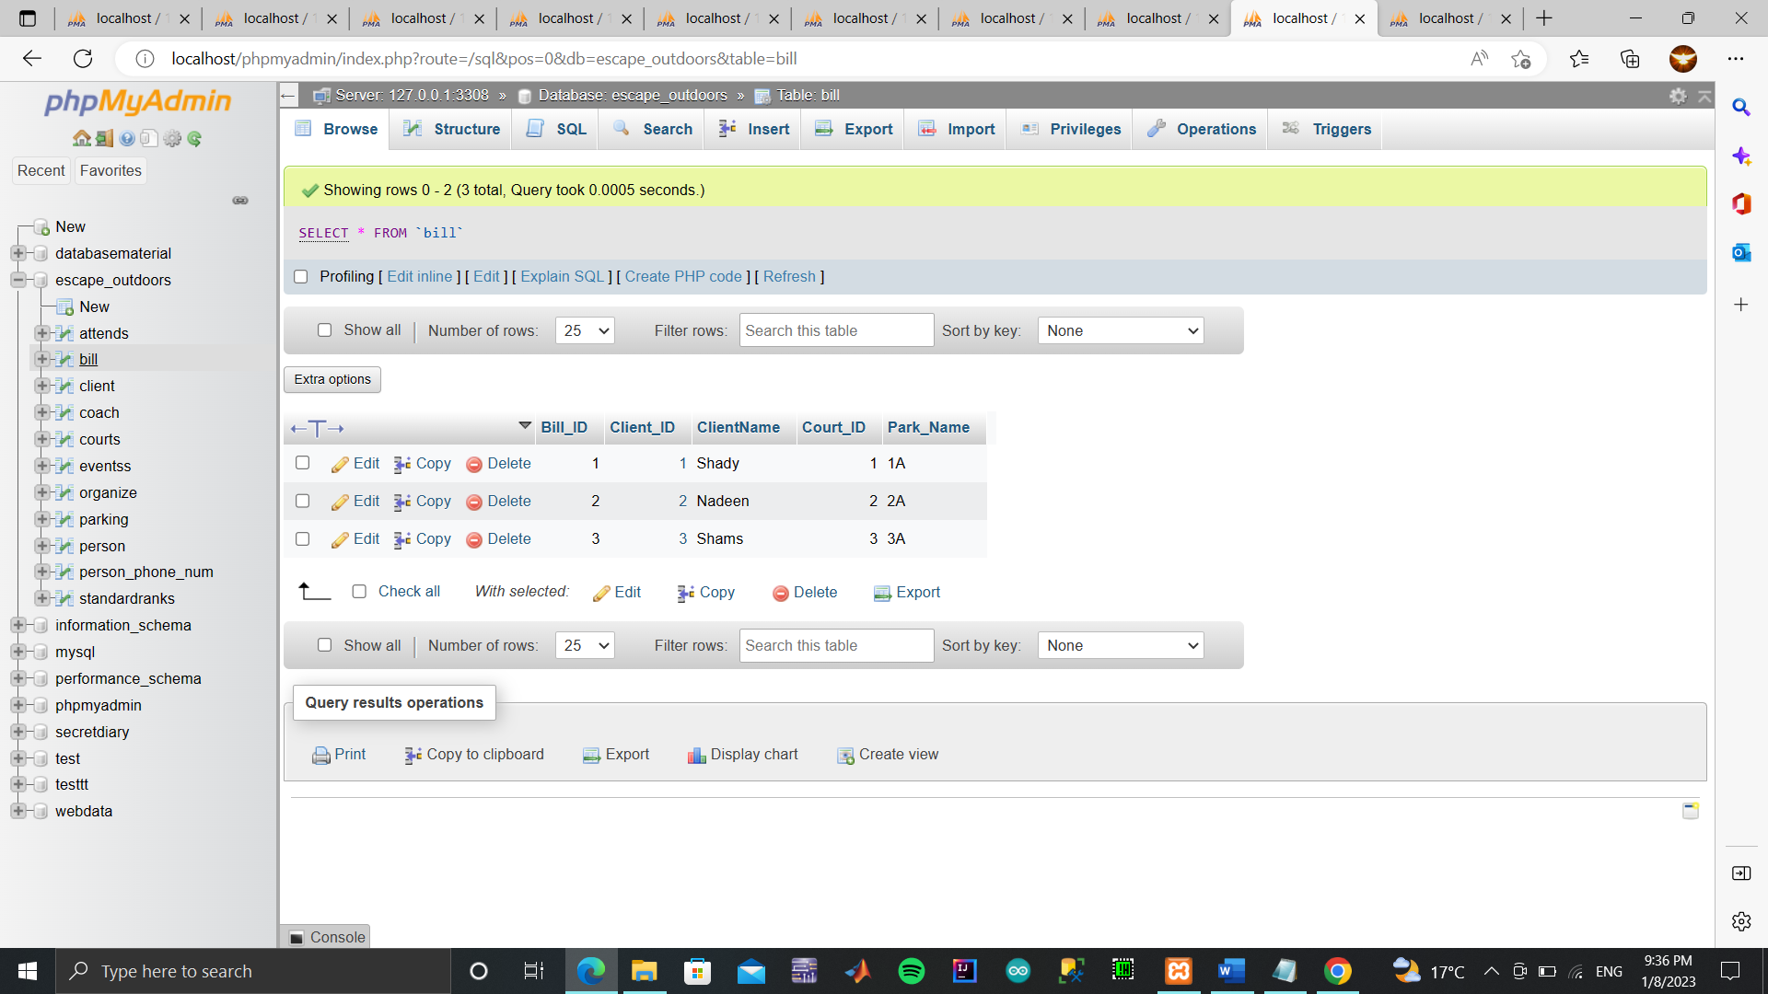

QUEIRIES

SELECT CName,CAddress,Rank,SRankName FROM client WHERE SRankName='Gold';

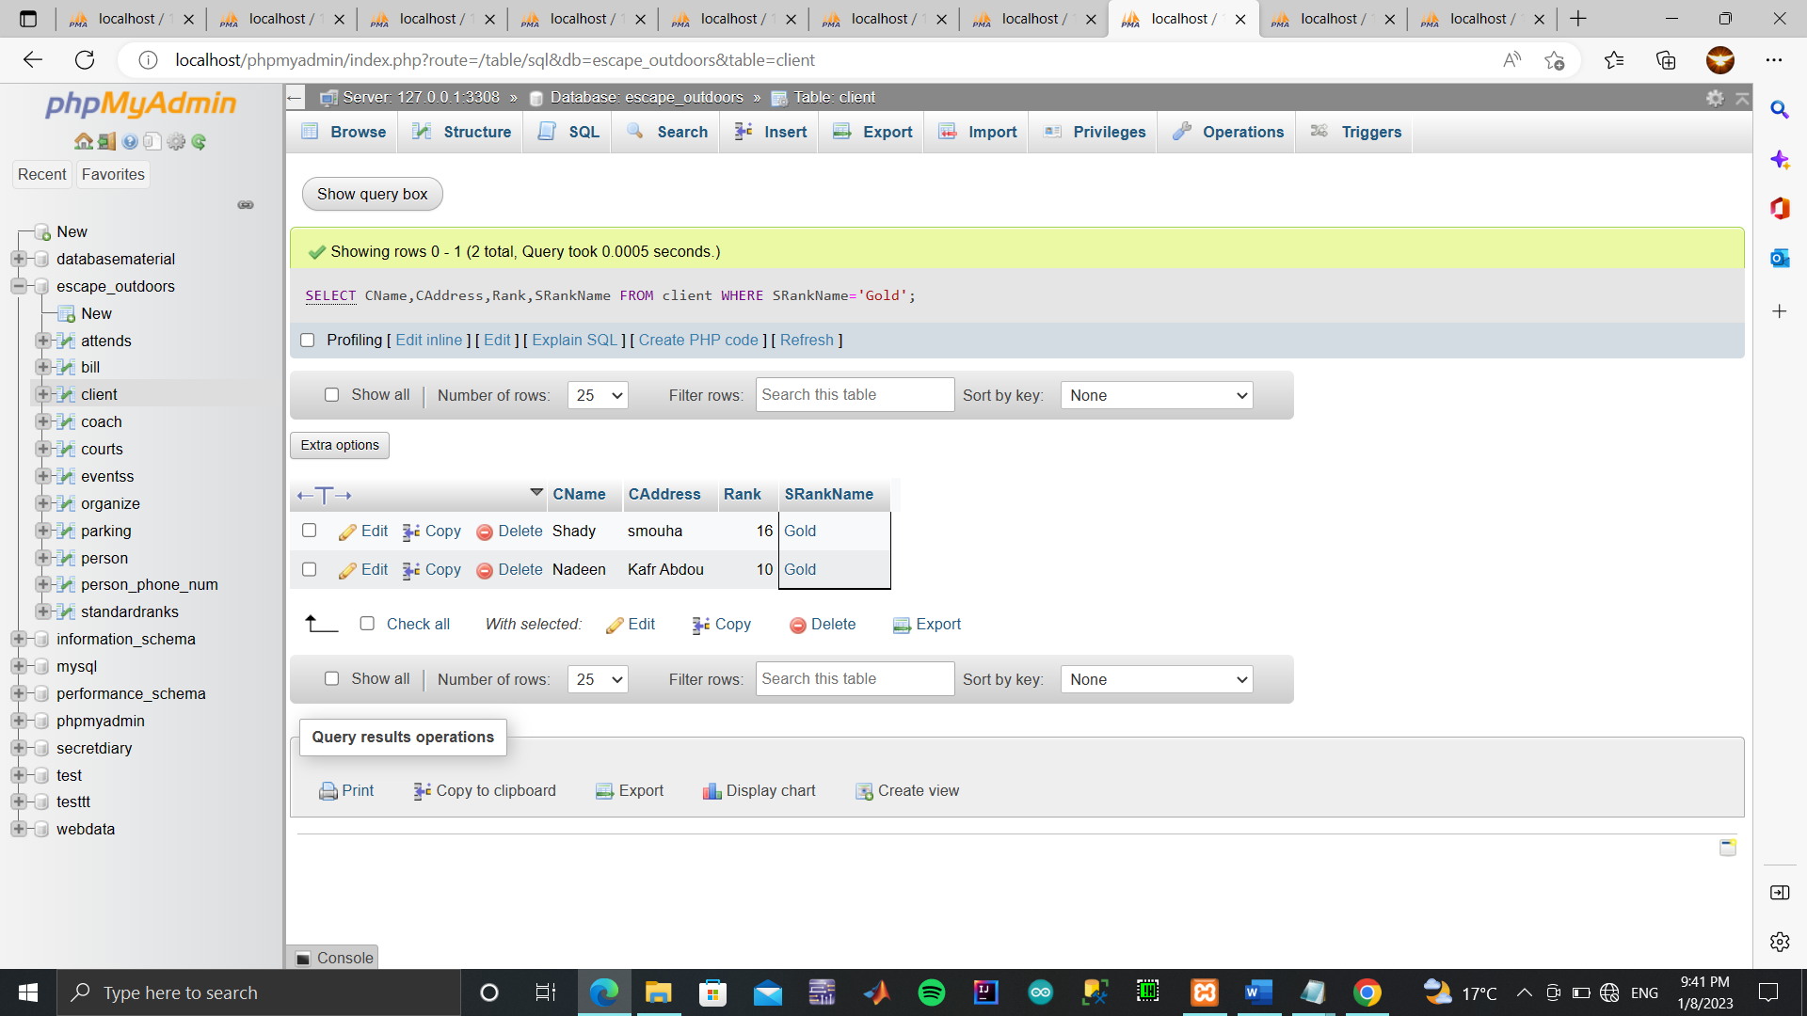

select CoName,Salary,Speciality

from coach

where Salary<10000;

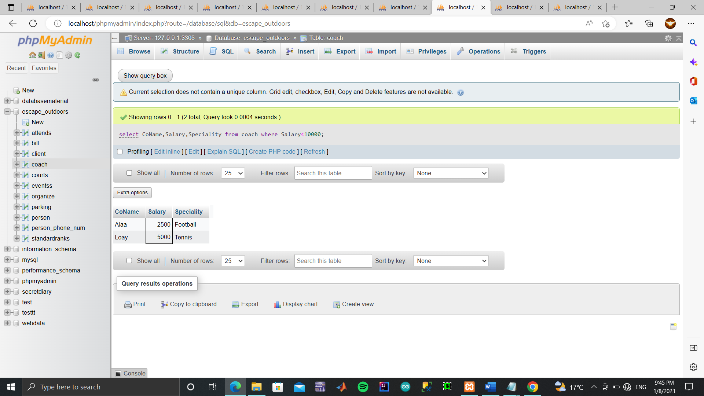

select Name,Maxlimit,PricePerHr

from courts

where Maxlimit = (select MAX(Maxlimit) from courts);

